MLL BELLINI COLLOQUIUM

Citizens of Memory: Recollection and Human Rights in Post-Dictatorship Argentina

Professor Silvia Tandeciarz
September 15, 3:30 pm
Washington Hall 315

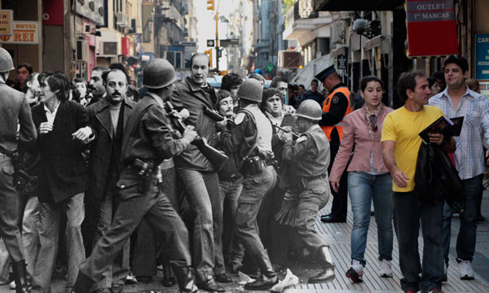
(Photomontage by Natalia Calabrese)
40 years after the military coup that ushered in the most brutal dictatorship of Argentina’s modern history, human rights activists, cultural practitioners and ordinary citizens continue to struggle to define its meaning. The tolls of this period are well known: thirty thousand disappeared; many more exiled and/or subjected to torture in clandestine detention centers; roughly five-hundred children born in captivity, taken from their biological parents and appropriated by Junta sympathizers to be raised according to its “Western and Christian” ideological principles; and a nation disciplined by the “Process of National Reorganization” whose regime of terror marked its transition from State to market.

While this story of State terrorism is not unique to Argentina, or to Latin America, the advances in human rights prosecutions of the last decade have turned the nation into a model of transitional justice. This lecture focuses on practices of recollection helped to shape the contemporary landscape. The analysis seeks to illuminate the productive confluence of aesthetic considerations and human rights practices, as well as the sometimes more fraught uses of memory, that this case study makes evident. The central proposition is that the creative labor informed by recall in contemporary Argentina is key not only to the nation’s ongoing project of democratization, but to the formation of citizens dedicated to the collective expansion of present and future spaces of hope. Talk begins at 3:45; gather @ 3:30 for refreshments!

