Please visit our website:
www.wm.edu/globalstudies

Special thanks to the organizing committee:

Anita Angelone, Modern Languages and Literatures
Tuska Benes, History
Bruce Campbell, Modern Languages and Literatures
Laurie Koloski, History
Rob Leventhal, Modern Languages and Literatures
Kathrin Levitan, History
Giulia Pacini, Modern Languages and Literatures
Leslie Waters, European Studies
Nadine Zimmerli, Omohundro Institute

Sports, Leisure,
Nationalism

Eighth Annual Student-Faculty Conference in European Studies

April 12-13, 2013

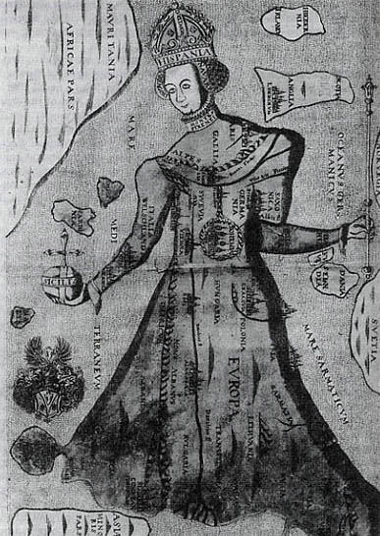

Sponsored by European Studies, the Mellon Foundation, and the Wendy and Emery Reves Center for International Studies

Friday, April 12

Keynote Address: 4:30 pm, Tyler 102

"Henri Desgrange, Cycling, and the Shape of the French National Body"

Rebecca Wines, Assistant Professor of French, Cornell College.

.

The European Studies
program at W&M is pleased
to present this student-faculty conference.

All events are free and open to
the public.

Saturday, April 13

Student Panels
Blow Hall 333

8:30 – 9:00: BREAKFAST

9:00 - 10:45: Leisure, Fans, and Athletes

Tyler Chapman, "Internationalism, Patriotism, and Utopianism in Belgium's Tomorrowland Music Festival"

Jessica Taylor, "Tourism and Cultural Identity in the Croatian-Italian Borderlands

Alexander Costa, "Losing my Identity: Local Fan Bases in the Globalized English Premier League"

Sarah Prowitt, "International Triumph: The Establishment of the Women's Olympic Marathon"

11:00 - 12:30: The Politicization of Sport

Pia Spinner, "Jewish Athletes in the Third Reich: Comparing Gretel Bergmann and Helene Mayer"

Ish Singh, "Is it Banter? The Evolution of Glasgow's Old Firm Football Rivalry"

Daniel Casey, "Politicizing the Apolitical: Global Sports Governance and the Breakup of Yugoslavia"

12:30 - 1:30: LUNCH and CLOSING REMARKS

